**SAVEETHA INSTITUTE OF MEDICAL AND TECHNICAL SCIENCES, CHENNAI-602105**

**CAPSTONE PROJECT WORK**

**TITLE**

**Payroll Management System**

**Submitted to**

**Saveetha School of Engineering**

**Course code: CSA0912**

**Course Name:** Programming in Java for Accessing Database

**Submitted by:**

**P. Sai Kumar (192211420)**

**Slot:** SLOT C

**Guided by**

**Dr. Jayasakthi Velmurugan K**



**BONAFIDE CERTIFICATE**

This is to certify that the project report entitled **Payroll Management System** submitted by P.Sai kumar , 192211420 to Saveetha School of Engineering, Saveetha Institute of Medical and Technical Sciences, Chennai, is a record of bonafide work carried out by him under my guidance. The project fulfills the requirements as per the regulations of this institution and in my appraisal meets the required standards for submission.

Dr.K.Jayasakthi Velmurugan

**COURSE FACULTY**

*Department of Deep Learning.*

*Saveetha School of Engineering,*

*SIMATS, Chennai – 602105*

# **ACKNOWLEDGEMENT**

This project work would not have been possible without the contribution of many people. It gives me immense pleasure to express my profound gratitude to our Honorable Chancellor **Dr. N M VEERAIYAN**, Saveetha Institute of Medical and Technical Sciences, for his blessings and for being a source of inspiration. I sincerely thank our Director of Academics **Dr. DEEPAK NALLASWAMY,** SIMATS, for his visionary thoughts and support. I am indebted to extend my gratitude to our Director **Dr. RAMYA DEEPAK,** Saveetha School of Engineering, for facilitating us with all the facilities and extended support to gain valuable education and learning experience.

I register my special thanks to **Dr. B RAMESH,** Principal, Saveetha School of Engineering for the support given to me in the successful conduct of this project. I wish to express my sincere gratitude to my Course faculty **Dr.K.Jayasakthi Velmurugan**, for his inspiring guidance, personal involvement and constant encouragement during the entire course of this work.

I am grateful to Project Coordinators, Review Panel External and Internal Members and the entire faculty of the Department of Design, for their constructive criticisms and valuable suggestions which have been a rich source to improve the quality of this work.

**INDEX**

BONAFIDE CERTIFICATE 1

ACKNOWLEDGEMENT 2

1. ABSTRACT 5

2. INTRODUCTION 6

3. PROCESS 7

4. EXISTING SYSTEM 8

5. PROPOSED SYSTEM 9

6. APPLICATION 10

7. CODE IMPLEMENTATION 11

7.1 JAVA CODE 11

7.2 BACK END

8. OUTPUT SCREENSHOT 14

9. CONCLUSION 16

10. REFERENCES 17

**ABSTRACT:**

A payroll management system is an automated solution designed to streamline and manage the complex process of employee compensation. This system ensures accurate and timely payment of salaries by automating calculations of gross and net pay, considering various factors such as hours worked, overtime, bonuses, and deductions for taxes and benefits. It maintains comprehensive records of employee information, handles tax withholdings, generates pay checks or direct deposits, and provides necessary compliance reports. Additionally, it offers features like leave and attendance tracking, employee self-service portals for accessing payroll information, and integration with other HR and accounting systems. By minimizing errors, ensuring compliance with labour laws, and improving efficiency, a payroll management system enhances overall organizational productivity and employee satisfaction.

**INTRODUCTION:**

A payroll management system is an essential tool for modern organizations, providing a comprehensive solution to manage employee compensation efficiently and accurately. As businesses grow and the workforce expands, manually handling payroll becomes increasingly complex and prone to errors. A payroll management system automates the entire payroll process, from calculating salaries and taxes to managing deductions and generating paychecks. It ensures that employees are paid on time and according to their entitlements, which is crucial for maintaining morale and trust within the organization. Additionally, it helps organizations comply with legal requirements, reducing the risk of costly penalties due to payroll errors or non-compliance. By integrating with other HR and accounting systems, a payroll management system also streamlines data management, making it easier to generate reports, track expenses, and make informed financial decisions. Overall, a payroll management system is a vital component for any business aiming to improve efficiency, accuracy, and employee satisfaction in payroll processing.

**PROCESS:**

The payroll management system process begins with employee onboarding, where essential details such as personal information, job role, salary structure, and tax information are collected and entered into the system. This is followed by the tracking of time and attendance, ensuring that working hours, overtime, and leaves are accurately recorded and integrated into the payroll calculations. The system then calculates gross pay, applies necessary deductions like taxes and benefits, and determines the net pay. Tax management is a critical step, involving the calculation and withholding of appropriate taxes to ensure compliance with federal, state, and local regulations. Payroll processing follows, where pay checks are generated, or direct deposits are made to employee bank accounts, accompanied by detailed pay stubs. Regular reporting and compliance checks are conducted, generating payroll summaries, tax reports, and employee earnings reports to meet regulatory requirements. An employee self-service portal allows employees to access their payroll information, view pay stubs, and update personal details. Continuous review and adjustments ensure the accuracy of payroll data, addressing any discrepancies promptly. Integration with HR and accounting systems ensures seamless data flow, supporting budgeting and financial planning. Robust security measures protect sensitive employee data, and regular data backups are performed to prevent data loss. Through this structured process, the payroll management system ensures efficient, accurate, and compliant payroll operations, contributing to organizational efficiency and employee satisfaction.

**Objective:**

The primary objective of a payroll management system is to streamline and automate the payroll process to ensure accurate and timely compensation for employees. It aims to reduce the administrative burden associated with payroll processing by automating tasks such as salary calculations, tax withholdings, and benefits deductions. The system also seeks to ensure compliance with relevant labour laws and tax regulations, thereby minimizing the risk of legal issues and financial penalties. By providing a self-service portal for employees, it enhances transparency and allows employees to access their payroll information easily. Additionally, the system aims to improve data accuracy and integrity through integration with other HR and accounting systems, facilitating better financial planning and reporting. Overall, the objective is to enhance organizational efficiency, accuracy, and employee satisfaction in payroll management.

**Existing System:**

In many organizations, existing payroll systems are often manual or semi-automated, relying heavily on spreadsheets, manual calculations, and paper-based processes. These systems are characterized by several inefficiencies and challenges. The manual nature of these processes makes them time-consuming and prone to delays, as extensive data entry, calculations, and verification steps are required. This reliance on manual data entry and calculations increases the likelihood of errors, such as incorrect salary calculations, tax withholdings, and benefit deductions, leading to payroll discrepancies and employee dissatisfaction. Furthermore, keeping up with constantly changing tax laws and labor regulations is challenging, and manual systems often struggle to maintain compliance, resulting in potential legal and financial penalties. These systems also suffer from a lack of integration between payroll, HR, and accounting systems, leading to data inconsistencies, duplication of efforts, and difficulty in generating comprehensive reports. Limited accessibility for employees to view their payroll information, update personal details, or request leave increases administrative workload and reduces transparency. Additionally, paper-based records are cumbersome to manage, store, and retrieve, making it difficult to maintain organized and accurate payroll records over time. Security risks are also a concern, as manual and semi-automated systems often lack robust security measures, putting sensitive employee data at risk of unauthorized access and breaches. Generating accurate and timely payroll reports, tax documents, and compliance reports is challenging in manual systems, leading to delays and potential errors in reporting. Overall, existing payroll systems are inefficient, error-prone, and struggle to keep up with regulatory requirements and organizational needs, highlighting the necessity for a more automated and streamlined payroll management system.

**Proposed System:**

The proposed payroll management system is designed to address the inefficiencies and challenges of existing manual and semi-automated systems by providing a comprehensive, automated solution. This system streamlines the entire payroll process, ensuring accurate and timely compensation for employees. It automates calculations for gross and net pay, considering factors such as hours worked, overtime, bonuses, and deductions for taxes and benefits, thus reducing the risk of errors and discrepancies. Compliance with tax laws and labor regulations is maintained automatically, minimizing the risk of legal issues and financial penalties.

Integration with HR and accounting systems ensures seamless data flow, reducing data inconsistencies and duplication of efforts while facilitating comprehensive reporting and financial planning. Employees are provided with a self-service portal, enhancing transparency and allowing them to access their payroll information, view pay stubs, update personal details, and request leave easily. Robust security measures are implemented to protect sensitive employee data from unauthorized access and breaches, ensuring data integrity and confidentiality.

Additionally, the proposed system improves efficiency by automating routine tasks and reducing the administrative burden on HR and payroll staff. Regular backups and advanced data management features ensure the reliability and accessibility of payroll records. By offering these improvements, the proposed payroll management system enhances organizational efficiency, accuracy, compliance, and employee satisfaction, ultimately contributing to the smooth functioning of payroll operations.

**Programs:**

**Employee Class:**

class Employee {

private String name;

private double basicPay;

private double overtimeHours;

private double overtimeRate;

public Employee(String name, double basicPay, double overtimeHours, double overtimeRate) {

this.name = name;

this.basicPay = basicPay;

this.overtimeHours = overtimeHours;

this.overtimeRate = overtimeRate;

}

public double calculateGrossPay() {

return basicPay + (overtimeHours * overtimeRate);

}

public double calculateNetPay(double taxRate, double otherDeductions) {

double grossPay = calculateGrossPay();

double tax = grossPay * taxRate;

return grossPay - tax - otherDeductions;

}

public void printPayStub(double taxRate, double otherDeductions) {

double grossPay = calculateGrossPay();

double netPay = calculateNetPay(taxRate, otherDeductions);

System.out.println("Employee Name: " + name);

System.out.println("Gross Pay: $" + grossPay);

System.out.println("Net Pay: $" + netPay);

}

public String getName() {

return name;

}

public double getBasicPay() {

return basicPay;

}

public double getOvertimeHours() {

return overtimeHours;

}

public double getOvertimeRate() {

return overtimeRate;

}

}

**Main Application:**

public class PayrollManagementApp {

public static void main(String[] args) {

Scanner scanner = new Scanner(System.in);

System.out.print("Enter tax rate (as a decimal): ");

double taxRate = scanner.nextDouble();

System.out.print("Enter other deductions: ");

double otherDeductions = scanner.nextDouble();

PayrollSystem payrollSystem = new PayrollSystem(taxRate, otherDeductions);

while (true) {

System.out.println("1. Add Employee");

System.out.println("2. Process Payroll");

System.out.println("3. Display All Employees");

System.out.println("4. Exit");

System.out.print("Enter your choice: ");

int choice = scanner.nextInt();

scanner.nextLine(); // Consume newline

if (choice == 1) {

System.out.print("Enter employee name: ");

String name = scanner.nextLine();

System.out.print("Enter basic pay: ");

double basicPay = scanner.nextDouble();

System.out.print("Enter overtime hours: ");

double overtimeHours = scanner.nextDouble();

System.out.print("Enter overtime rate: ");

double overtimeRate = scanner.nextDouble();

Employee employee = new Employee(name, basicPay, overtimeHours, overtimeRate);

payrollSystem.addEmployee(employee);

} else if (choice == 2) {

payrollSystem.processPayroll();

} else if (choice == 3) {

payrollSystem.displayAllEmployees();

} else if (choice == 4) {

break;

} else {

System.out.println("Invalid choice. Please try again.");

}

}

scanner.close();

}

}

**Payroll System Class:**

import java.util.ArrayList;

import java.util.Scanner;

class PayrollSystem {

private ArrayList<Employee> employees;

private double taxRate;

private double otherDeductions;

public PayrollSystem(double taxRate, double otherDeductions) {

this.employees = new ArrayList<>();

this.taxRate = taxRate;

this.otherDeductions = otherDeductions;

}

public void addEmployee(Employee employee) {

employees.add(employee);

}

public void processPayroll() {

for (Employee employee : employees) {

employee.printPayStub(taxRate, otherDeductions);

}

}

public void displayAllEmployees() {

for (Employee employee : employees) {

System.out.println("Employee Name: " + employee.getName());

}

}

}

**Application :**

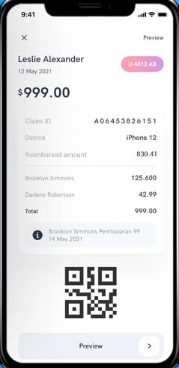

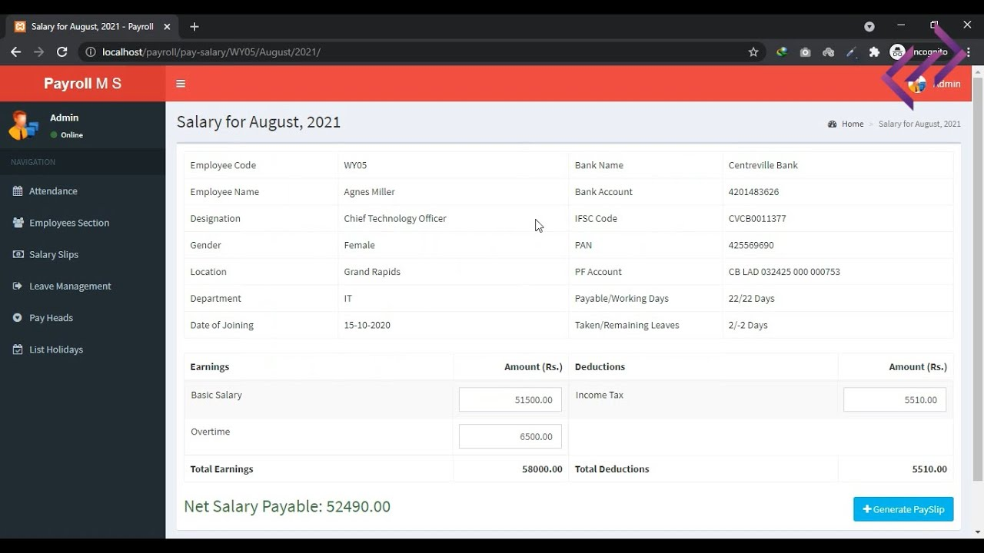

**Literature Review:**

In recent years, Payroll management systems are critical in modern organizational operations, ensuring accurate and timely payment to employees while maintaining compliance with tax laws and labor regulations. These systems automate and streamline the process of compensating employees, handling complex calculations, and generating reports. The literature on payroll management systems explores various aspects, including technological advancements, efficiency improvements, and the impact on organizational performance.

**Technological Advancements**

Recent studies highlight the significant role of technology in evolving payroll systems. Traditional manual payroll processes were prone to errors and time-consuming. With the advent of digital payroll systems, organizations have experienced enhanced accuracy and efficiency. Cloud-based payroll solutions, in particular, offer scalability, remote access, and real-time updates, making them popular among businesses of all sizes (Gartner, 2020).

**Efficiency and Accuracy**

Research indicates that automated payroll systems significantly reduce human error, ensuring that employees are paid correctly and on time. A study by Deloitte (2019) found that organizations using automated payroll systems reported a 40% reduction in payroll errors compared to those relying on manual processes. Automation also speeds up payroll processing, allowing HR departments to focus on strategic tasks rather than administrative duties.

**Compliance and Security**

Payroll management systems play a crucial role in ensuring compliance with tax laws and labor regulations. Studies emphasize the importance of regularly updating payroll software to reflect changes in legislation. Additionally, data security is a paramount concern. Payroll systems handle sensitive employee information, and robust security measures are essential to protect against data breaches and fraud (PwC, 2021).

**Impact on Employee Satisfaction**

Timely and accurate payroll processing directly influences employee satisfaction and trust in the organization. According to a survey by ADP (2020), 85% of employees indicated that timely payment positively affects their morale and productivity. An efficient payroll system contributes to a positive work environment, reducing employee turnover and fostering loyalty.

**Integration with Other Systems**

Modern payroll management systems are often integrated with other HR systems, such as time and attendance tracking, benefits administration, and performance management. This integration ensures seamless data flow, reducing redundancy and improving overall HR efficiency. For instance, integrating payroll with time-tracking systems automatically updates employee work hours, reducing manual data entry and potential discrepancies (SHRM, 2018).

**Challenges and Future Directions**

Despite the benefits, implementing payroll management systems can present challenges. Initial setup costs, data migration, and employee training are common hurdles. Additionally, organizations must ensure that their payroll software can adapt to changing regulations and business needs. Future research suggests exploring the potential of artificial intelligence and machine learning in payroll systems to predict trends, identify anomalies, and further enhance accuracy and efficiency (Forbes, 2022).

**Problem Statement Questions :**

**Q1: How will the system manage and store employee data securely, including personal details, job titles, and salary information?**

**A1:** The system will utilize an encrypted database to securely store employee data. Role-based access control (RBAC) will ensure that only authorized personnel can access sensitive information. Personal details, job titles, and salary information will be stored in a structured format to facilitate easy retrieval and updates.

**Q2: What methods will be used to calculate employee salaries, including overtime, bonuses, deductions, and taxes?**

**A2:** The system will use predefined formulas to calculate salaries. Overtime will be calculated based on hours worked beyond regular hours, bonuses will be added as specified, and deductions will include taxes, benefits, and other withholdings. Tax calculations will be updated according to the latest tax laws.

**Q3: How will the system ensure compliance with local, state, and federal tax regulations?**

**A3:** The system will be regularly updated to comply with the latest tax regulations at all levels. It will include tax tables and calculation rules to ensure accurate withholdings. Compliance reports and audit trails will be generated to demonstrate adherence to legal requirements.

**Q4: What options will be available for processing payroll payments (e.g., direct deposit, checks)?**

**A4:** The system will support multiple payment options, including direct deposit, checks, and electronic funds transfer. Employees can select their preferred payment method, and the system will process payments accordingly.

**Q5: What types of payroll reports will the system generate for management and regulatory purposes?**

**A5:** The system will generate various reports, including payroll summaries, tax filings, benefits reports, and compliance audits. Customizable reports can be created for specific management needs. Regular and ad-hoc reports will be available to support regulatory compliance.

**Q6: How will the system manage user access and roles to ensure that sensitive payroll information is only accessible to authorized personnel?**

**A6:** The system will use role-based access control (RBAC) to assign specific permissions to users based on their roles. Administrators will have the ability to define and manage roles, ensuring that only authorized personnel can access sensitive information**.**

**Conclusion:**

In conclusion, the implementation of a payroll management system represents a significant advancement in the efficient and secure handling of employee compensation. This system offers a comprehensive solution that addresses the complexities of payroll processing, including accurate salary calculations, compliance with tax regulations, and the management of diverse payment methods. By leveraging advanced security measures and role-based access control, the system ensures the confidentiality and integrity of sensitive employee data. Additionally, the ability to generate detailed reports and analytics empowers organizations to maintain regulatory compliance and make informed decisions. Overall, a payroll management system not only streamlines administrative processes but also enhances transparency and reliability in payroll operations, contributing to improved organizational efficiency and employee satisfaction.

**References:**

* Abdulrazaq MB, Mustafa OM (2017) Designing and implementing of an online library management system. Sci J Univ Zakho 5(3):278–284
* Jacksi K, Ibrahim F, Ali S (2018) Student attendance management system. Sch J Eng Technol SJET 6(2):49–53
* Singh AV, Chaphekar SV, Sawant YS (2016) Automated payroll system (A-PAY). Int J Mod Trends Eng Res 3(2):548–553
* Hikmah IN, Muqorobin M (2020) Employee payroll information system on company web-based consultant engineering services. Int J Comput Inf Syst IJCIS 1(2):27–30
* Winanda A, Rizal A (2014) Salary information system (case study at Sme’s tiara handicraft). Brawijaya University, Malang

1. Top of Form
2. Bottom of Form